**Cornwall Councillor Report – Mevagissey Parish Council – December 2024**

I hope everyone is enjoying December and the run up to Christmas, it’s certainly been a busy month for me so far and it’s less than halfway through at the time of writing.

The weekend of 7-8 December was dominated by Storm Darragh and some seriously blowy winds. During times like this, I am always pleased to act as a conduit for local people in reporting the various hazards that occur to Cormac so they can stay on top of what was undoubtedly a hectic weekend right across Cornwall.

On Saturday alone I reported more than twenty fallen trees across my division, several of which had taken out power cables, causing blackouts in Pentewan Valley that lingered on over the whole weekend. This continued onto Sunday with trees falling all over the place. Thank you to parish councillors and residents for your help in getting them properly documented and reported and well done to Cormac and its contractors who worked flat out through the weekend in difficult conditions to deal with the worst falls.

It was really interesting to attend the Mevagissey area business event at the social club.

A good turnout to hear from speakers including Cornwall Chamber of Commerce CEO John Brown, Visit Cornwall, Laura from the Lost Gardens of Heligan, business memtor Steve Minton, Alex Williams and Parish Cllr Jon Gann about some of the challenges facing Cornwall and Mevagissey in particular, as well as ideas from attendants on coming together for some potential solutions.

As a non-business owner it was a privilege to listen in and speak to so many people from a variety of industries about the common issues they all face, and what can be done to help and support them, although the subsequent news last week of further economic shrinkage in October provides even more of a challenge, and we must all do our bit where we can to support our local business community through these tough times.

It was brilliant to go the very well attended Climate Resilient Mevagissey launch at the MAC with presentations from the Environment Agency, Climate Vision, the Westcountry Rivers Trust and support from South West Water and Cornwall Council.

I have been delighted to support several of the projects spoken about last night, in particular earlier this year along with former MP Steve Double we lobbied and wrote in support of the joint Westcountry Rivers Trust and Cornwall Council bid for natural flood management for the Mevagissey catchment.

It was great to see this bid successful and to see it already being developed, with a helpful chat with Westcountry Rivers Trust CEO Laurence Couldrick to discuss next steps and future projects and funding opportunities.

This sort of project needs strong community support, both from Mevagissey and in particular the surrounding farmers, and there is no one better to lead on this than the inspirational Luci Isaacson. Engagement about flooding issues can be very negative for obvious reasons, but Luci has a fantastic outlook, looking at achievable and practical solutions to the issues and always positively gets these points across to the many meetings and audiences I've seen her present at.

Finally, this was an excellent example of the MAC being used as a great venue for this event, well done to everyone involved in arranging it and I look forward to seeing these projects progress in the future.

From Cormac it was good to see that the consultation on the proposed speed limit changes on the dangerous section of road from Tregiskey Crossroads to Valley Road is now live, and I hope to see this concluded and the measures implemented in the New Year.

Since my last report, I was pleased to speak in support of the motion to support our family farms against the Government’s proposed changes. which I seconded, and see this motion backed by all Conservative, Liberal Democrat and Mebyon Kernow Councillors, as well as most of the Independent ones. I was sorry to see that the Labour Councillors and the one Green Party Councillor did not back it.

These changes, which include restrictions to Agricultural Property Relief (APR) and Business Property Relief (BPR), are being called a ‘Family Farm Tax’ due to their devastating impact on family farms and rural communities. I spoke up on behalf of farmers in my division, who gave me powerful testimony about how they feel these changes will impact them and their families.

This is a cruel policy based on fundamental misunderstandings from a Labour Government and its supporters who are either woefully out of touch with rural communities or just don’t care, and is nothing more than weaponised and poorly targeted ideological warfare against some of our hardest working families.

I am pleased that we have done what we can as a council and spoken up on behalf of our farmers and added our voice to theirs in speaking out on these damaging changes and pushing for the change that is needed at this difficult time.

In terms of other big issues, I wanted to highlight the proposals announced last week by the Government around changing the planning system.

It can be a lot of work for me, but 'calling in' planning applications, for refusal or approval at the planning committee, has always been in my view and important and democratically necessary part of the planning system, allowing parish councils to have their say when they don't agree with Cornwall Council's planning department's recommendations.

Now the government is effectively recommending removing this part of the planning process as part of their planning reforms. They say that,

*'for applications that comply with local development [there are] plans to bypass planning committees entirely'.*

It should be noted that applications are normally only referred to Committee for refusal if we believe they are not compliant with planning policy, against the recommendations of officers, who will say they are compliant.

Sadly I think this is a step backwards, with the Government’s plans to allow developers to quickly build thousands of houses over-ruling the valid views of the communities these houses will be built in.

With the new waste and recycling regime in place, this is the first Christmas where we have had this. Cornwall Council have produced this helpful graphic which shows when any rearranged general waste or recycling collections will take place:

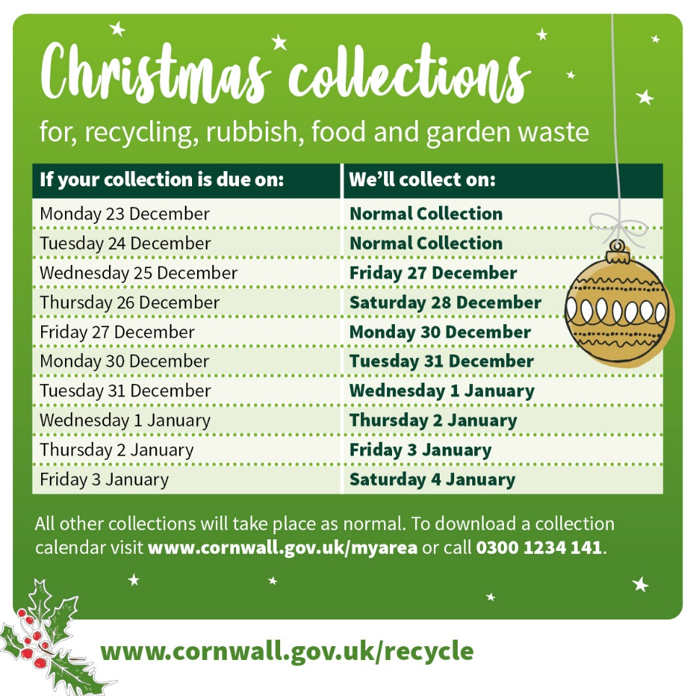

Finally I’d like to thank everyone for your support over what has been a busy year, and wish you all a Merry Christmas and a Happy and Healthy 2025.

As ever, should people wish to get in touch, they are very welcome to do so, via cllr.james.mustoe@cornwall.gov.uk or at 07885277670