**Cornwall Councillor Report – November 2024 – Mevagissey Parish**

I hope you are all well as we go through November.

On 10 November it was an honour as ever to take part as a Civic dignitary in my 11th Remembrance Service as Cornwall Councillor for Mevagissey. Reading the list of the fallen really brings home the sacrifices made by the men and families of our parish in the two world wars, to conflicts as recently as Afghanistan, so that we can live in freedom today.

On highways matters as we are now out of the busy summer season, there has been or will be a fair amount of roadworks taking place by utility providers such as National Grid and South West Water. These organisations are what as known as ‘statutory undertakers’ and can plan and put in roadworks with little reference to Cornwall Council as the local highways authority. With that being said, I can ask them to move their signs and work more pro-actively if they are not sticking to the plans that they have agreed to, such as in the past week, when National Grid got a permit to close a small section of Fore Street but then turned up and closed all of Fore Street and the bottom of Tregoney Hill! This was resolved quickly with a call to Streetworks but it is always helpful to be informed about what is actually happening on the ground by local residents and business owners, so I can take actions if needed.

On another highways issue, the water that ran from the triangle at Tregiskey down the road onto the B3273 was one that I have reported to Cormac on many occasions previously.

As we are now getting into colder weather I have recently visited the area and taken photos and video evidence of the issue and reported it to Cormac again.

Cormac said they were imminently going to be doing some work there to clear back the vegetation between the Farm and the crossroads, to uncover any hidden gullies and ensure water runs in the channel and not out onto the public highway.

They attended later that week and cut back muck and vegetation to reveal a highways gully that had been completely buried. Needless to say it is now working again and the water is flowing into it – thanks to Cormac for sorting this.

Away from highways matters, at the end of the last half term it was great to visit Mevagissey School to meet with Headteacher Mr Ringrose, attend their Harvest Festival Assembly, donate to the harvest collection, give some tulips to the gardening club kindly supplied via Cormac, and then join the gardening club to dig up some potatoes! It was particularly good to hear the enthusiastic rendition of 'Big Red Combine Harvester'!

In more good news from the Shared Prosperity Fund works that have transformed the entrance to the historic Mevagissey and District Museum, as well as renewing the museum’s roof, have been completed.

The works were made possible in part by £52,746.51 of funding, from the Community Levelling Up Programme and matched by £20,000 raised from the community.

This funding has been allocated from Cornwall Council’s Community Levelling Up Programme. The Community Levelling Up Programme is part of the Good Growth Programme, which is delivering the UK Shared Prosperity Fund in Cornwall and Isles of Scilly.

Thanks in particular to local craftsman Geoff Barham for leading on the work to renovate this iconic part of our village, to ensure that its history and heritage will be enjoyed by many more generations over the years to come.

Mevagissey and District Museum will be having a grand opening on March 30th 2025 to celebrate these works being completed. All are welcome.

I had a number of complaints about the standard to which Ocean Housing’s contractors had left Wesley Court and Meadow Street following their recent work on the site, in particular regarding them not painting the pebble-dashed walls, and leaving paint all over the pavement and road. Ocean have now replied as follows:

*• ‘Paint on road: This wasn’t connected to the decorating works that are currently taking place with our appointed sub-contractor. However, it was the result the of a spill from a paint can from one of our vehicles as it left site following works in a void property. We have attended to this and if necessary, we will carry out further power cleaning of that area if there is any residual staining. We have spoken to the operative involved and have dealt with the matter internally.*

*• Pebble dashed walls: The decoration and cleaning is still currently a ‘work in progress’ at Wesley Court.*

*It isn’t industry standard to paint over a pebble dashed wall and it is not recommended. The standard treatment advised by technical decorating specifiers, Akzo Nobel/Dulux, is that the walls are cleaned down using a ‘soft wash’ process to prevent forced water ingress and damage to the dash finish. The soft-wash removes loose dirt, mould, vegetable matter etc. To prevent further residual growth the surfaces are then treated with a fungicidal wash.*

*You can see from the pictures attached, the ‘before’ condition and the ‘after’ results following this process. Although the difference isn’t as stark as a freshly painted surface, there is an improvement considering the limitations when restoring a dash finish.’*

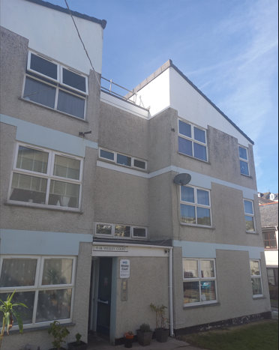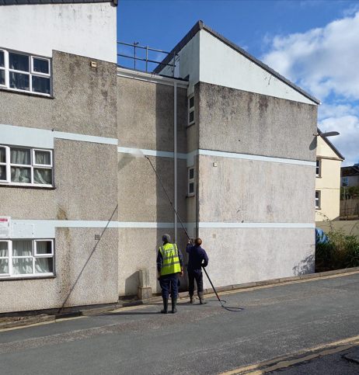

I also challenged Ocean again on their plans to sell another affordable home in Mevagissey (Kiln Close) with no replacement affordable housing for the parish factored in. Their response has been forwarded to the parish council.

On 26 November at Full Council I am seconding a motion that sets out:

1. To request that the Leader of the Council writes to the Secretary of State for Environment, Food and Rural Affairs to outline the Council’s dismay at the decision in the Budget to restrict Agricultural Property Relief and calls on the Government to stop the Family Farm Tax.

2. That the Cabinet Member for Environment and Climate Change engages with local farmers and community representatives to consider what support the Council can provide to support them.

While my division no longer has the very rural St Gorran Parish in it, there are still farms in every parish that I represent, as well as people who work in the many industries that support or are reliant on our local farms.

As a predominantly rural Duchy or county, with a greater percentage of small family owned farms than other rural areas, Cornwall does stand to be more harshly impacted by these proposals than other parts of the country, and with this in mind, it is only right that we are asking Cornwall Council to do what it can to both directly support our farmers in their time of need, as well as lobby the government with what I hope will be a unanimous voice to get these changes, which I am sure were not intentionally designed to inflict so much potential damage on family businesses, to be reviewed and reversed as soon as possible.

Finally I was quite surprised to realise that 6 November marked the tenth anniversary of my first election as Cornwall Councillor, way back in 2014, and thus the beginning of my 11th year in office.

It remains a great privilege to serve or to have served the people, businesses and communities in the parishes of Mevagissey, St Gorran, Pentewan Valley, St Austell Bay and Carlyon over the years.

As ever, should people wish to get in touch, they are very welcome to do so, via cllr.james.mustoe@cornwall.gov.uk or at 07885277670