**MEVAGISSEY PARISH COUNCIL**

mevagisseyparishcouncil.co.uk

Minutes of the Parish Council Meeting held at the Mevagissey Activity Centre on Thursday 19 January 2023 at 7.00 p.m.

Present: Cllrs. M Facey (Vice Chair), A Williams, J Whatty, A Christie, G Williams, J Gann, J Brown.

In Attendance: Cllr James Mustoe (CC), T Cailleach (Clerk to the Council)

***Unratified unless signed***

1. Apologies were received from Cllr M Roberts (Chairman) Cllr J Morgan, Cllr G Barham and Cllr G Shephard.
2. Vice Chairman’s expressed on behalf of all the Councillors Condolences to Chairman Roberts and family and confirmed the date of the funeral for Mrs Beryl Roberts was at 10.30 a.m. on the 1 February at Glynn Valley.

The statutory period for calling an election to fill the Parish Council Vacancy has expired and Notices of the Vacancy are on the Ship Notice Board. No applications have been received. One position remains vacant on the Parish Council.

1. No Declarations of Interest or Gifts.
2. Public Questions or Comments. Laura Nicholson from Lower Well Park attended and commented on the Mevagissey Bay Hotel that the proposed building will be higher and offices that would be occupied each day with subsequent loss of space and amenity to dwellings in Lower Well Park. She has put a comment in on the Appeal.
3. Minutes of the Council

Cllr Williams then proposed that the Minutes of the meeting on the 17 November 2022 were accepted as amended. Seconded by Cllr J Whatty. **Carried**

1. Cllr Gann proposed the Minutes of the meeting on the 18 November 2022 were accepted Seconded by Cllr J Whatty. **Carried**
2. The Clerk reported
3. Donations towards the costs of providing the Village Bins have been made by:

A Blackmore (The Cornish Fish) in the sum of £200:

K J Pratt (The Fish Grill) in the sum of £300:

Cllrs expressed their gratitude for the contributions.

1. Mevagissey Lights thanked the Council for the Grant of £100, although were hopeful or a larger sum. The Grants Policy has now been adopted for future applications.
2. Notification has been received of increases to the costs of providing the Parish Council services and energy costs. Quotes to be obtained from suppliers to be circulated to identify the best deal.
3. British Gas suddenly changed the postal address to a combination of the former and current postal address causing further delay to receipt of Invoices experienced by the postal strike.
4. Some Contractors and Cornwall Council departments still emailing to the now defunct former Parish Clerk’s email address. Long term this will be addressed by the Gov.uk email.
5. A new external auditor has been appointed fees to be confirmed once the Budget has been established as this will be based on projected income and expenditure. Clerk requested confirmation that Robert Larter again be appointed for an internal audit. Cllr J Whatty proposed the appointment of Robert Larter as internal auditor Seconded by Cllr A Williams. **Carried**
6. Two further complaints received in respect of Sunny Corner Car Park. One visitor to Mevagissey confirms she will go to Court with Premier Parking Solutions.
7. Neighbourhood Development Plan on the website to be updated by Cllr J Whatty to reflect the final appendices.
8. Request for the “Proud to Care” advert Cornwall Council to go on the website and Facebook. Cllrs instructed the Clerk to send to Cllrs J Whatty and J Gann.
9. Request from Royal Cornwall Health Trust to place a Specification for a Patient Leader on the Parish Council website and/or Facebook. Cllrs instructed the Clerk to send to Cllr J Gann for Facebook.
10. St Austell Bay Clerk Masters Research Survey on the “Public Value of Parish Councils” has been received. Cllrs in attendance instructed the Clerk to provide their email so they can complete the Cllrs Survey.
11. HSBC Bank plc St Austell Branch is closing on the 18 April 2023 and Ian Warne will be Manager at Truro.
12. The Salt/Grit Bins have been identified on Cornwall Council Interactive Mapping Tool and 16 placed in the Mevagissey Parish. An Order form confirms the costs for refilling. The Cllrs considered how the Parish Council can manage the process of identification of icy areas and maintaining salt/grit in the Bins given that all Cllrs are voluntary. Cllr J Brown will explore the possibility of local salt/grit volunteers and report back to the Cllrs. It was identified that Grit/Salt will need to be ordered and identification of a suitable place for storage.

Cllr A Williams proposed costs of up to £400 could be incurred to obtain a Pallet of Grit/Salt. Seconded by Cllr J Gann. **Carried.**

1. Cormac believe an area of land at River Street is not the responsibility of Cornwall Council. Ward Member J Mustoe is liaising with a resident of Elm Terrace.
2. LexisNexis are funding £23.00 and provided the up-to-date version of “Arnold-Baker on Local Council Administration” at a discount.
3. Ward Member presented his Report having arranged a meeting with Cabinet Member for Housing and Planning Olly Monk and representatives of the Parish Council leading to a visit to the Parish from Cornwall Council again meeting with Parish Council representatives. He also reported on Cormac works to be carried out and investigations and meeting with MP Steve Double and the Fishermen’s Association and the Harbour Trust. Important steps have been taken to charge holiday lets and second home non primary residences 100% additional council tax from 2024. The full Report can be seen on the Parish Website.
4. **November Finances**



Cllr G Williams proposed acceptance of the November Finances. Seconded by Cllr Whatty. **CARRIED**

**December Finances**

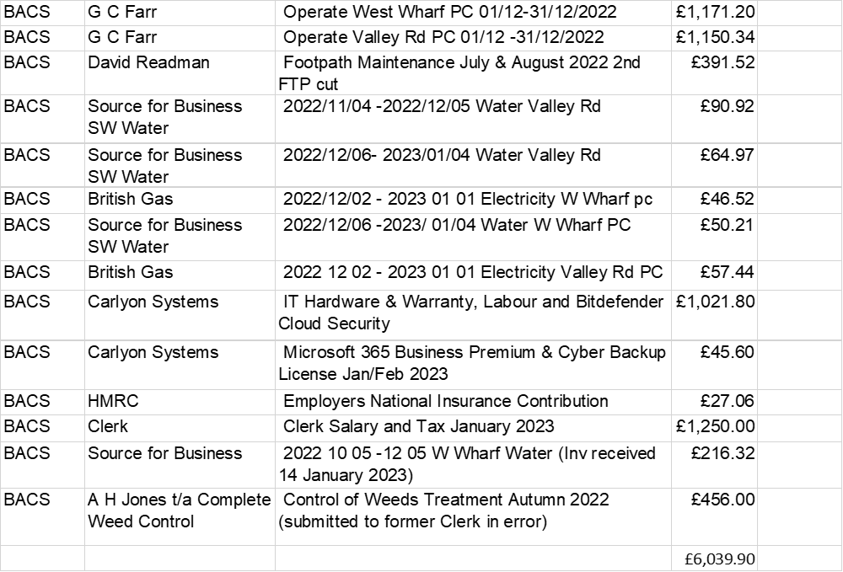

Cllr A Williams proposed the December Finances were accepted. Seconded by Cllr J Brown. **Carried.**

1. Budget 2023-2024 Preparations for the Budget need further consideration in the light of the missed December and length of the Agenda Cllr J Gann proposed a Finance Committee of the Signatories on the Bank Account meet to prepare a Draft Budget 2023/24 for consideration by the full Parish Council in February 2024 to enable full consideration of financial matters. Seconded by Cllr J Whatty. **Carried**
2. Cornwall Council have confirmed the Inland Footpath and South West Coast Footpaths Maintenance will be for 2023/24.
3. IT – Website, email and PC. The Order submitted and further information will follow when available.
4. Working Party - Mevagissey Climate Emergency Action Group Report. Cllr A Christie has stepped down as Chair and resigned. Cllr J Brown is Chair and reported that the Community event Winter Well Being in conjunction with the MC went well. A further community event with the Mevagissey Community Support Group in conjunction with the school, date to be confirmed. There may be a need for a further carbon footprint reporting.
5. Working Party – Mevagissey Public Toilets Working Group Report. Slides were shown following completion of the decorating and maintenance works in the Autumn. West Wharf have suffered mould due to the conditions and a report of the works and costs required to halt the spread was given with photos of the affected areas. Cllr J Gann proposed authorisation for the repairs to be given. Seconded by Cllr J Brown. **Carried.**
6. The Annual Responsibilities Schedule newly created was considered. It was noted that the Grit/Salt Bins will need adding for checking before the Winter season and in the New year annually. It was discussed when Bins supporting local businesses should begin and when service of Notice to terminate the Bins. It was established this will be March/April commencement and Notice to terminate served in mid-October.
7. It was noted that the National Association of Local Councils Civility and Respect Pledge has been tabled and EDM for debate in the House of Commons regarding the bullying harassment and intimidation across the Parish/Town/Community Councils sector. Cllr A Williams proposed adoption of the Civility and Respect Pledge in the light of its importance and Cllr J Brown Seconded. **Carried.**
8. Devolution was deferred to the February meeting.
9. Heligan and Tremayne Estates Update - Cllr Brown reported that unfortunately Heligan does not have what is needed to pursue the joint project of a community garden. Cllr J Whatty will make enquiry regarding land in the Parish that may be suitable for Allotments and will report back.
10. Inclusion Cornwall “Cost of Living Resource Sheet” was deferred to the February meeting.
11. Bodrugan Hill – cutting back and highway concerns was discussed. Ward Member Mustoe confirmed information had been provided to the parish resident who had raised a concern about growth of boundary hedges that are the responsibility of landowners. Cllr J Whatty proposed changing the order of the next two items Seconded by Cllr J Brown. **Carried.**
12. Pebble House Polkirt Hill Mevagissey Certificate of Lawfulness was discussed as the Parish Council’s response to the application and the evidence submitted are not visible on the Online Register. Cllr J Gann proposed that the Clerk seek confirmation that these documents submitted by the Parish Council were received, understood and analysed and informed the decision made on the 11 November. Seconded by Cllr J Brown. **Carried**.
13. Planning Appeal PA21/07498 Mevagissey Bay Hotel Demolition of hotel and redevelopment of site with five apartments. The draft note of the response to the Appeal submitted was discussed and Cllr A Williams proposed the draft note is the formal Parish Council response. Seconded by Cllr J Whatty. **Carried.**

The meeting ended at 9.00 p.m. Date of next meeting (not Planning) 16 February 2023 at 7.00 p.m..

Signed……………………………………. Signed………………………………….. Dated