**MEVAGISSEY PARISH COUNCIL**

mevagisseyparishcouncil.co.uk

Minutes of the Parish Council Meeting held at the Mevagissey Activity Centre

On Thursday 20 October 2022 at 7pm

Present: Cllrs. M Roberts (Chairman), M Facey, G Barham, G Shephard, K Chamberlain, J Whatty, A Christie, G Williams, J Gann, J Brown, C Leiser.

In Attendance: Cllr James Mustoe (CC), Harbour Master Andrew Trevarton, Architect Nick Bailey, T Cailleach (Clerk to the Council)

***Unratified unless signed***

1. Apologies were received from Cllrs Morgan, Drake, A Williams.

The Chairman announced that Cllr Leiser had resigned as she will take up a new role in Namibia and thanked her for commitment to the Council and residents of Mevagissey. All expressed gratitude for the work she had undertaken and wished her well for the future.

1. Declarations of Interest or Gifts. None.
2. Item 4 was brought forward Mr Andrew Trevarton Harbour Master presented to the meeting plans and photos of proposed works for access to Island Beach to allow safe public access, so far over 50 letters of support have been received by the Harbour Trustees. Cllrs questions were answered in respect of disabled access and safety measures. Confirmation was given jet skis will not be permitted. Nick Bailey Architect was also present to answer any questions on the plans. The support of the Council was requested. The Council budget for the financial year 2023-24 has yet to be prepared and a response will be given once that has been finalised.
3. Public Questions or Comments. None.
4. Minutes of the Council

Correction of the minutes of 29 September 2022 Item 20 was proposed by Cllr Facey that the draft Letter be sent to the Parish Resident Seconded by Cllr Barham. Carried

Cllr Facey then proposed that the Minutes 29 September 2022 were accepted as amended. Seconded by Cllr Barham. Carried

1. Cllr Barham proposed the minutes of the 30 September 2022 were accepted Seconded by Cllr Facey. Carried
2. Clerk reported

The Clerk has received a second Summons for Jury Service beginning 21 November 2022, having deferred once having started new employment second deferments are not usually possible except with extenuating circumstances. There will therefore be a delay in preparation and publication of the minutes in view of the Clerk’s statutory obligations of Jury Service. It should be noted that the Standing Orders do not require the Minutes to be published within a specified time it is merely good practice to issue these as soon as possible.

The HSBC formalities have been concluded.

Correspondence from summer visitors received and replied to.

Online Training completed “Internal Controls” various on “Best Practice” at the Scribefest Online Conference.

1. External Audit confirmation of completion confirmed early October. Items on the Asset Register can have a nominal value of £1 where the original purchase price and value are unknown. Ward Member Mustoe confirmed that the Salt Bins belong to Cornwall Council and it was noted that these are on Public Highways.
2. Ward Member presented his Report and this can be seen on the Parish Website.
3. Monthly Finances

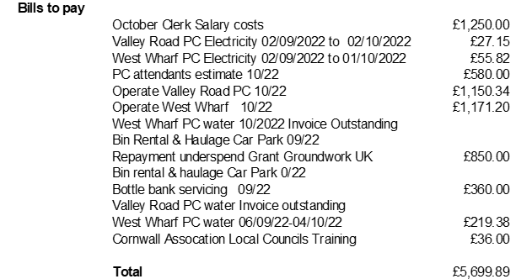

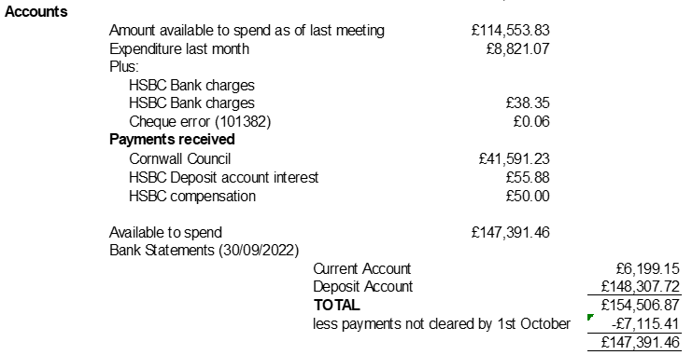

Proposed by Cllr Shephard Seconded by Cllr Christie Carried

1. The Draft Grant Application form was presented and considered and s137 Local Government Act 1972 discussed. Cllr Gann proposed that a Grants Policy be implemented Seconded by Cllr Brown and Cllr Barham will prepare a draft Grants Policy for discussion and add contact details for the Parish Council to the draft Application Form.

Carried

1. Outsourcing Payroll quotations discussed, the most favourable is from D M Payroll recommended by Pontesbury Parish Council proposed by Cllr Facey that the Clerk instructs D M Payroll Seconded by Cllr Barham. Carried.
2. Cllr Facey reported on the progress of the Skateboard Park proposals and costings and application to the Shared Prosperity Fund.
3. Cllrs Christie and Brown reported on the Shared Prosperity Fund application with The Lost Gardens of Heligan. Cllrs discussed Risk Assessment, deadlines, beneficiary and leadership given the size and significance of the Proposal. Cllr Brown confirm it was intended to proceed by way of a limited company.
4. The Council had sought guidance about amendment of the Neighbourhood Development Plan to incorporate the Adopted Climate Action Plan. Neighbourhood Planning Cornwall Council have confirmed that further planning changes are anticipated from central Government and it is important to wait until those changes are known. It was acknowledged as encouraging that the Climate Action Plan does mirror many aspects of Cornwall Council’s County wide plan.
5. Discussion of the email response from Cllr Monk and the meeting with Ocean Housing. It was important to note that a meeting date has not been proposed by Cllr Monk and the Clerk was asked to pursue this to discuss the legalities of the section 106 and clarify the legal position.

Ocean Housing proposals to sell to ReSi Housing Ltd had been outlined at a recent meeting. On the information available the Cllrs who attended that the Parish Council identified it was not possible to judge the business model proposed.

1. Cllr Leiser confirmed 1,000 trees will be delivered to Valley Road Car Park for residents ~~and~~ the delivery date anticipated **yet to be confirmed** is 3 December. One site identified for planting ~~identified~~ and the adjoining property owner has expressed support. Cormac ~~are~~ to be contacted. Three Bays Wildlife can be contacted regarding this following Cllr Leiser’s departure.
2. The Working Groups composition was confirmed. Cllr Facey proposed Cllr Brown be voted onto the Climate Emergency Working Group Seconded by Cllr Leiser. It was confirmed ~~that~~ the Community Land Trust Working Group has become now known as the Mevagissey Housing Working Group. Carried
3. The Notice Board location at the Rising Sun is both risky and difficult to use. The screws and fittings fused, now eased thanks to local resident Mr T White. Cllr Christie proposed investigations for replacement and ~~that~~ the Clerk should contact Sharon at the Rising Sun about location to progress further. Seconded by Cllr Whatty. Carried
4. Cllr Whatty provided brief information to the meeting about progress towards adopting a gov.uk website and email.
5. The meeting ended at 10.10 p.m. Date of next meeting (not Planning) 17 November 2022.

Signed……………………………………. Signed………………………………….. Dated 2022