**MEVAGISSEY PARISH COUNCIL**

mevagisseyparishcouncil.co.uk

Dear Councillor

You are summoned to attend the next meeting to be held at the Mevagissey Activity Centre on Thursday 20 October 2022 starting at 7 p.m.

Planning matters will be dealt with at a separate meeting on Friday 21 October 2022.

Teri Cailleach

Clerk to the Council

October 2022

07370 832669

[mevaclerk@gmail.com](mailto:mevaclerk@gmail.com)

*Please note that under the Openess of Local Government Bodies Regulations 2014 this meeting may be recorded.*

**AGENDA**

1. Apologies for Absence
2. Declarations of Interests and Gifts.
3. Public participation.
4. Mevagissey Harbour Trustees

*To receive a proposal from Andrew Trevarton Mevagissey Harbour*

1. Minutes of the meeting held on 18 August 2022

*Correction Item 20 of the Minutes should have contained the Resolution for the Clerk to respond to the parish resident proposed by CLLR NAME Seconded by CLLR NAME. Subject thereto to resolve that the minutes of the above meeting be signed as a correct record of the meeting.*

1. To accept the Minutes of the meeting held on the 19 August 2022.

*To resolve that the minutes of the above meeting be signed as a correct record of the meeting.*

1. Clerk’s Report

*Verbal update from the Clerk on matters progress since last ordinary meeting.*

1. Internal and External Audit

*To receive the External Audit Conclusion*

1. Cornwall Councillor’s Report

*To receive a report from Cllr James Mustoe CC*

1. To approve the monthly finances.

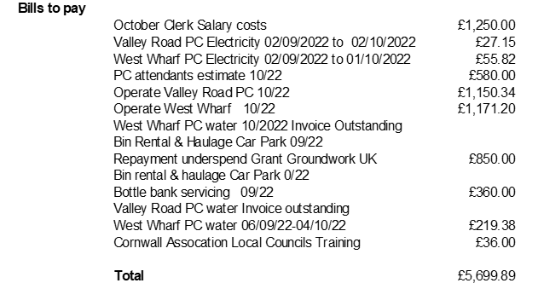

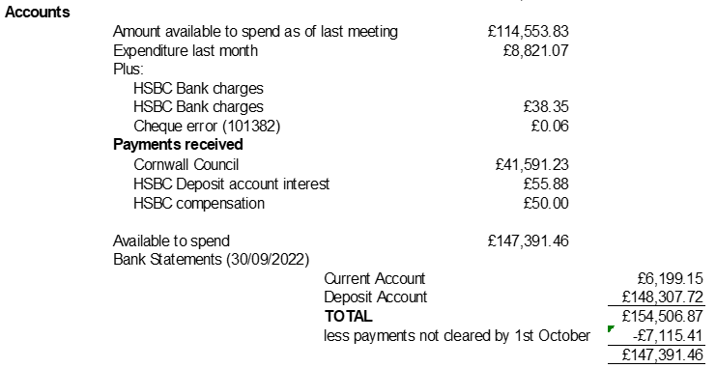

1. Application form for Grants and s137 Local Government Act 1972

*To review, accept/amend and adopt the Grant Application form.*

1. Outsourcing Payroll

*To review estimates for Outsourcing and authorise appointment*

1. Skateboard Park

*To receive a report from Cllr Facey*

1. Heligan and Tremayne Estates

*To discuss creation of a link with the Parish Council (Cllrs Christie and Brown).*

1. Neighbourhood Development Plan and Mevagissey Climate Action Policy

*To consider the response from Colleen O’Sullivan Cornwall Council Neighbourhood Planning Team and receive an update from Cllr Chrisite*

1. Mevagissey Affordable Housing – Designated Protected Areas

*To discuss Cllr Monk’s response to the Housing Working Group and the meeting with Ocean Housing*

1. Tree Planting – Forest for Cornwall

*Cllr Leiser will provide an update.*

1. Parish Council Working Groups

*To prepare a list of the Working Groups and list Councillors in each Working Group.*

1. Rising Sun Notice Board

*To consider replacement of Notice Board with key mechanism and location given how precarious access is.*

1. Date of next meeting (not Planning) 17 November 2022.

*NOTE: The meeting will include an opportunity for members of the public to make representations and give evidence on any item appearing on this Agenda.*

*No member of the public may speak longer than three minutes. The meeting has been advertised as a public meeting and as such could be recorded by broadcasters, the media or members of the public.*